
Climate Action Plan
Trinity School

1 year plan Autumn 2025 – 2026

Your school’s carbon baseline: 2,074 t CO₂e Calculation: November 2025 Year

= = high carbon reduction actions

Climate Action Plan history
Last reviewed: | March 26
Notes: These figures are to be used as an indicative estimation.

Progress Key
Not Started
In Progress
Stalled
Complete
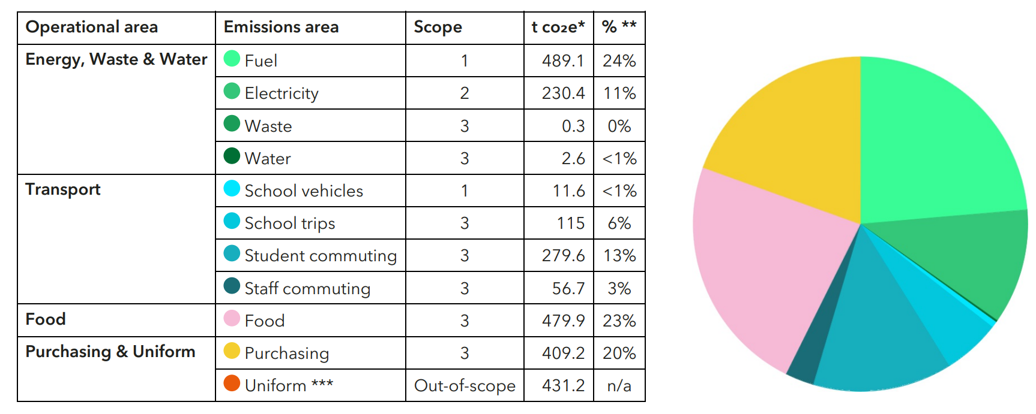

Overall projected carbon savings: 8% to 21% 21%%
Get started
ACTION | NOTES | TRACKER
Sign up to the Let’s Go Zero campaign  By joining this campaign, your school confirms that it is taking action now to reduce its own carbon impact, and that it demands the UK Government help all schools reach this goal by the end of the decade. | Signed up to the campaign and requested to work with a climate ambassador.  Audit completed | Complete
Calculate your school’s carbon footprint using Count Your Carbon  This free digital tool allows you to calculate the carbon footprint for your educational setting and gives you a baseline against which to measure progress, year on year. | Count your carbon survey completed and shared in advance of the audit meeting. | Complete
Add sustainability plans, projects and successes to your school website and share through wider communications  Celebrate your school’s climate action on your website, in newsletters, social media, local press, and events to showcase your successes and involve the wider community. Use the Let's Go Zero comms pack to do this. | CAP plan finalised after the audit meeting to be shared on the website. | In Progress
Set up a sustainability working group  Assemble a Sustainability Working Group featuring different stakeholders across the school to collaborate and effect change. Ensure one person has oversight, taking the title of 'Sustainability Lead' and where possible provide PPA time for this role. | Form a working group to include Business manager, Site manager, Catering manager, IT manager, Assistant Headteacher  Termly meetings to discuss any progress in the plan. | In progress
Join the CDEC Sustainability teacher network  Ideas and good practice shared across the county – Cumbria Development Education Centre | Joined the group | In progress

1. Decarbonisation and Energy Efficiency
Calculating and taking actions to reduce carbon emissions and becoming more energy efficient
Energy – Buildings and retrofit
ACTION | NOTES | TRACKER
★ Optimise your BMS/BEMS settings and ensure your heating and hot water systems have efficient timings and temperatures set  18ºC is the general recommendation for classroom temperatures, whilst hot water coming out of taps should be no higher than 43ºC (stored at 60ºC). Experiment with your heating schedule while maintaining comfort - running it one hour less per day or reducing temperatures by 1 degree can cut annual heating costs by 5–10%, according to the DfE. | BMS reviewed each morning with alterations made where appropriate and serviced by external company Astral Controls monthly | Complete
★ Double glaze all windows where possible  Replace any single glazed windows with double glazing or add secondary glazing to enhance energy efficiency, save money, reduce external noise and create a more accessible learning environment. | 6th form buildings – Complete replacement to all single glazed  Rolling programme for the few remaining single glazing | Complete
Install LED lighting  Replace any remaining older lighting fixtures with LEDs and install motion sensors in areas that see only intermittent use. The DfE suggests LED installation can reduce energy consumption from lighting by over 84%. | Rolling programme to replace with LED units | In progress
Investigate the potential for solar panels  Find out who you need permission from and contact solar providers to check the suitability of your roof spaces and the financial models available (direct purchase, lease, community energy). Aim to compare approaches from at least three different providers to check you are getting options that work well for your setting. Providers we suggest checking with: Solar for Schools & Eden Sustainable. | Recommendation to compare current quote with Solar for Schools. Trinity School Data Estimate.  Preliminary enquiries made | In progress
Commission an energy audit or heat decarbonisation plan  This is a top recommendation for schools who are looking to invest in infrastructure changes to reduce energy costs and will help you to identify and prioritise the next steps with energy retrofit options and measurements for your school. | Large scale window replacement complete.  CIF bid for significant roof repairs submitted | In progress
Energy – behavioural change
ACTION | NOTES | TRACKER
Take part in a switch off campaign  Take part in a switch off campaign, e.g. Switch Off Fortnight. Aim for 10% reduction of energy use (the typical amount saved by participating schools). Running campaigns before the holiday period (such as a summer switch-down) can lead to reduced energy use over the holiday period. | Holiday campaigns in place | Complete
Implement a power down strategy for electrical devices and appliances  Implement power-down strategies across the school, such as sleep and automatic shutdown settings on computers, projectors, and smart boards, and switching off scanners and printers overnight. You can use a mix of automatic (e.g. timer-controlled switches) and manual shutdown approaches depending on need. | Quote for an automatic switch off system for all computers.  Staff survey used to determine best times for the nightly switch off. | In Progress
Use workspaces efficiently to limit the need for heating and lighting during and after the school day  Create a smart timetabling system for before and after-school community usage, and for staff usage on non-teaching days to limit the spaces that need to be lit and heated. | Heating and lighting controlled for use before and after school.  Accommodation restricted during holiday periods with heat and lighting correctly controlled | Complete
Implement a power down strategy for energy-intensive appliances over holidays  Fridges and freezers are often over-looked during holiday and closure periods and require a lot of energy to run. Check every fridge, including the staffroom, and turn them off over holiday periods. Condense frozen food down to only one freezer to reduce baseload during unoccupied periods and turn off any other freezers. | Staff survey which fridges and freezers are essential to leave switched on. All others identified, emptied and switched off each holiday.  Include in holiday campaign.

Food
ACTION | NOTES | TRACKER
Encourage sustainability using the reuse/ rethink Strategy  Raise student awareness regarding the effect single use containers, cups etc have on the environment.  Increase the use of plates instead of cartons. | Canteens to promote reuse by using crockery where possible.  Canteens to promote rethink by offering a discount on hot drinks when using reusable cups and a surcharge on take-out food in disposables containers (Bistro).

Waste
ACTION | NOTES | TRACKER
Provide students with education on the importance of reducing, reusing and recycling correctly  Teach students about the waste hierarchy: 'Reduce -> Reuse -> Recycle' through a variety of assemblies, workshops and initiatives. These could be run by your eco-team, local authority, or waste contractor. Teach how recyclables are processed and the importance of reducing single-use and supporting a circular economy. Organisations such as Wastebuster and Recycle Now have a variety of curriculum-linked resources. Your CAA can provide additional resources on request. | Assembly themes adapted to cover this. | In progress

Procurement
ACTION | NOTES | TRACKER
Replace ICT equipment that is at end of life with energy efficient alternatives  Purchase new IT equipment based on energy efficiency ratings and consider buying second hand refurbished IT equipment to lower the cost and carbon footprint. | ICT equipment is replaced at end of life with consideration given to energy efficiency ratings | Complete
Factor in energy efficiency when buying new equipment such as ovens, fridges, kettles etc.  Ensure that cost is balanced against the efficiency rating of electrical appliances to compensate upfront cost with running cost and longevity, e.g. Choosing only appliances that are the highest efficiency rating for that product. | Consideration given to energy efficiency ratings when purchasing appliances | Complete

Transport
ACTION | NOTES | TRACKER
★ Replace school vehicles with EVs  Once at the end of their life, replace any existing school vehicles with electric vehicles. | Consideration will be given when vehicles are at end of life. | Stalled till it is relevant
Consider environmental impact of school trips  Reduce the distance or investigate more sustainable travel options. | Trips involving flights are uncommon  Local destinations used wherever possible  Trip proposal form has section on sustainability on | In progress

2. Climate adaptation and resilience
Taking actions to reduce the risk of flooding and overheating and to future-proof scarce resources for potential shortages

Adaptation and resilience
ACTION | NOTES | TRACKER
Conduct a climate resilience audit  Conduct a climate resilience audit of the school site, e.g. To check all windows and blind open and close, guttering, planting etc. The Climate Ready School Grounds survey from Learning Through Landscapes covers all weather conditions and involves students' opinions of their grounds. | Routine inspections, servicing and repairs in place  BMS adjusted when required to allow for changing weather | Complete

Water
ACTION | NOTES | TRACKER
Raise awareness around water consumption and efficiency  Consider engaging with your local water company who may have an education team or free resources on their websites, from assembly sessions and visits to primary schools for your pupils to webinars, downloadable tools and guides, and more. | Assembly themes adapted to include this. | In progress

3. Biodiversity and Green Infrastructure
Creating habitats and adopting practices that will enhance species diversity on the school estate and beyond

Nature
ACTION | NOTES | TRACKER
Take part in The Nature Park  The Nature Park aims to embed nature-based learning into the curriculum and encourage children and young people all over the country to take action to improve their site for people and wildlife. The programme provides the support and guidance needed to make this happen, with five key steps in the journey and the actions needed to reach your goals. | Start with drawing the boundary of the school site | Stalled
Ernest Cook grant  Apply for grant from Ernest Cook for outdoor activity. | Applied for grant, determining plan. | In progress

4. Climate Education, Green Skills and Green Careers
Ensuring the education you provide gives knowledge-rich and comprehensive teaching about climate change, and that your teaching staff feel supported to offer this

Culture
ACTION | NOTES | TRACKER
Sign up to Sustainability Support for Education  A DfE-funded project that enables education settings to start or progress on their sustainability journey. This includes all types of settings from Early Years to Higher Education, offering suggested actions paired with quality-assured resources. You can filter these to show suggestions relevant to your setting based on your teaching age, priorities, how far you’ve progressed already, estate, and more. | Signed up | Stalled
Set up an Eco Club or Eco Council for pupils to lead on sustainability initiatives  Establish a student Eco-Club or Eco Council. Consider inclusivity and longevity of projects so that as many students as possible can take part throughout their time at school. | Students to represent Trinity at Youth Climate Summit  Let’s Start a Student Eco-club guide  TLR post to be advertised | Stalled

Green skills and careers
ACTION | NOTES | TRACKER
Include celebrating Green careers week, and include at least one green career per subject in careers fortnights. | Careers advisor to celebrate green careers week. | In progress
Access the Climate Ambassadors scheme  Connect with Climate Ambassadors in your region and invite them to do school assemblies on green skills and curriculum linked topics. | Invitation sent. | In progress




www.letsgozero.org

Ashden is registered in England and Wales as a company limited by guarantee.
Registered number: 05062574/ Charity number: 1104153
The Peak, 3rd Floor 5 Wilton Road, London, SW1V 1AP

