

TEACHER OF MATHEMATICS
FULL TIME AND PERMANENT
REQUIRED FOR SEPTEMBER 2026

The Mathematics Department
The Mathematics department at Trinity School is staffed by a dedicated team of thirteen strong mathematicians and able practitioners, and prides itself on the way it works together. The team meets regularly to discuss curriculum developments, and all members are willing to try, develop and create innovative ideas to push the department forward. Staff make excellent use of the CPD on offer via support networks including the AMSP and Mathshub and are at the forefront in terms of research informed teaching practice.
On entry in Year 7, students are set into streamed groups and have four teaching hours per week. During Years 7, 8 and 9, the curriculum is streamlined with Sparx to maximise the impact of homework. We have a curriculum set up to promote the mastery of mathematical skills, prior to starting the GCSE in Year 10. Presently, students study the EDEXEL GCSE with entry in the summer of Year 11.
A Level Mathematics is taught to the EDEXCEL specification, attracting around 35-40 students each year, making it one of the most popular A level subjects.

The Post
This post would suit a well-qualified, enthusiastic and innovative Maths specialist, either a newly qualified or more experienced teacher. The ability to teach A-Level Maths would be highly desirable, but is not essential.

What to do next
We hope that these details have helped you decide that you would like to apply for this post. Please fill in the application form and write a letter of no more than two sides about your work so far, and what we would gain if you joined our school.

Send the completed application form and your letter explaining why we should be thinking about appointing you to Mrs Judith Clarke, PA to the Headteacher, Trinity School, Strand Road, Carlisle, CA1 1JB or email jcl@trinity.cumbria.sch.uk by 9.00am, Wednesday 18 March 2026.

You are welcome to contact us in advance if you would like to know more about us, or have other questions about the post, the school or the area. Please contact Judith Clarke on 01228 403551.

We look forward to receiving your application.

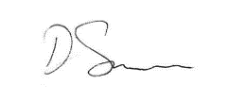
David Samson

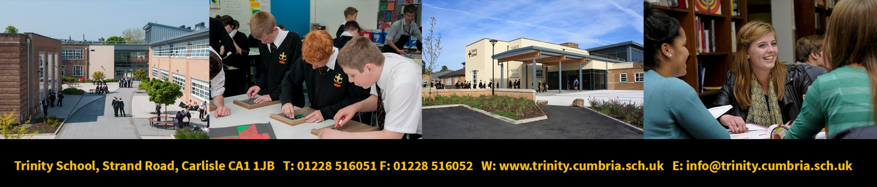
Headteacher

