5 December 2025
Dear Parent/Carer
Relationships, Sex and Health Education (RSHE) is an important part of our commitment to supporting students’ personal development and wellbeing. RSHE is delivered mainly during form time and covers a wide range of themes, including healthy relationships, staying safe, decision-making, emotional wellbeing and preparation for adult life. All topics are age-appropriate and designed to help students make informed and responsible choices.
Our full RSHE curriculum plan can be accessed via the Trinity School website here:
https://trinity.cumbria.sch.uk/wp-content/uploads/2025/01/RSEHE-Policy-Personal-Development-Curriculum-Plan-2024-2025.pdf
The statutory RSHE guidance outlining what schools are required to teach is available here from page 25:
https://assets.publishing.service.gov.uk/media/68b96b003f3e5483efdba9b4/Relationships_Education_RSE_and_Health_Education.pdf
Whilst in most cases we would advise against it, based on our knowledge of content, and its relevance to our young people, parents and carers have the right to request that their child is withdrawn from the sex-education elements of RSHE (those beyond the national science curriculum). Any request should be made in writing to info@trinity.cumbria.sch.uk - FAO Mr Samson, Headteacher. To assist with our planning, we would appreciate any such request being submitted before 16th January. Please note that parents may withdraw their child up to three terms before the child turns 16. After this point, the pupil has the right to opt back into sex education if they wish.

If you have any questions about RSHE please do not hesitate to contact me.
Kind regards,
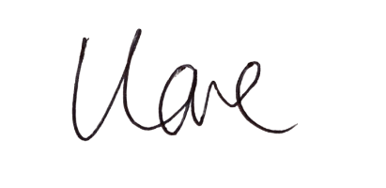
Mrs L Love
Assistant Headteacher

